TXSeries-COBOLIT-IVP

# Docker Build Fails

Dear kishkulk,

During build using docker file in txseries-samples, it fails as COBOLIT product image file (**COBOLIT tar.gz**) is not part of it

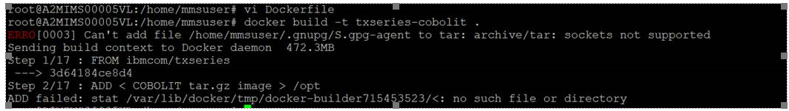

Pls can u advise on the source for it?

Regards – Arun

Email – arunajithan@gmail.com